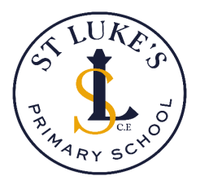

**St Luke’s C.E. Primary School**

**Mathematics Policy**

**Langport Avenue**

**Longsight**

**Manchester**

**M12 4NG**

**St Luke’s Mission Statement**

***We believe in providing our pupils with the skills to be resilient, independent and brave. We look to God to help us be loving neighbours, caring stewards and reflective individuals. We do this through a rich diverse curriculum, which is inclusive, accepting and supportive.***

***‘For with God, nothing shall be impossible’*** (Luke 1:37)

**What this looks like in Maths**

In Maths at St Luke’s, we are neither afraid nor ashamed of our mistakes. Instead, we reflect upon them, learn from them and share what we have learnt with others to help build our resilience and independence.

When children are finding something hard, it can be easy to give up. At St Luke’s, we actively

encourage them to look for help from ‘The 3 B’s’ in this order: their **books** (looking through their book can remind them of useful strategies), their **buddies** (the other children on their table), then their **boss** (a member of staff!) This encourages independence and reflection.

Collaborative working, where peers support one another to achieve, enables children to build one another up alongside the ongoing active feedback from staff. Children learn to be loving neighbours and steward their skills by using them to help others.

At St Luke’s, our Maths groups are fluid and tailored to meet the dynamics of individual lessons. Teacher assessment throughout lessons ensures that children who need extra support will receive it, whilst children who are ready for a challenge will get one! It’s not just our children who are encouraged to be reflective; our teachers are too!

**Rationale**

Mathematics is key skill within school and a life skill that is used throughout our daily experiences; it equips us with a powerful set of tools to understand and change the world. These tools include logical reasoning, problem solving skills and the ability to think in abstract ways. At St Luke’s, we therefore endeavour to develop a positive attitude towards mathematics that will improve children’s confidence as they journey through their lives.

The National Curriculum for Mathematics (2014) describes in detail what pupils must learn in each year group. It ensures continuity, progression and high expectations for attainment in mathematics.

At St Luke’s, we use the National Curriculum for Mathematics (2014) as the basis of our mathematics programme. The White Rose Scheme of Work is what we use to ensure that our pupils access a rich and progressive curriculum and achieve to their maximum potential. Using a clear scheme means that all pupils are given equal opportunities to flourish and master the maths skills that they will need in later life. Maths talk, ongoing assessment, an emphasis on investigation and problem solving, the development of mathematical thinking and the development of teacher subject knowledge are therefore essential components of our approach to this subject at St Luke’s.

**Intent: What are the aims and objectives of our Mathematics Curriculum?**

At St Luke’s, our Maths curriculum **aims** to promote and develop the following attributes in all our pupils:

* a positive ‘can do’ attitude to mathematics as an interesting and attractive part of the curriculum;
* the ability to think clearly and logically, with confidence, flexibility and independence of thought;
* a deeper understanding of mathematics through a process of enquiry, experiment and investigation;
* an understanding of the connectivity of patterns and relationships within mathematics;
* the ability to apply knowledge, skills and ideas in real life contexts outside the classroom, and become increasingly aware of the uses of mathematics in the wider world;
* the ability to use mathematics as a means of communicating ideas;
* an ability and inclination to work both alone and cooperatively when solving mathematical problems and to reason, think logically and work systematically and accurately;
* personal qualities such as perseverance, independent thinking, cooperation and self-confidence through a sense of achievement and success;
* an appreciation of the creative aspects of mathematics and an awareness of its aesthetic appeal;
* competence and confidence in mathematical knowledge, concepts and skills, providing a solid foundation to lead on to secondary and further education.

This supports the aims of the National Curriculum for Mathematics (2014), which aspires for pupils to:

* *become* ***fluent*** *in the fundamentals of mathematics, including through varied and frequent practice with increasingly complex problems over time, so that pupils develop conceptual understanding and the ability to recall and apply knowledge rapidly and accurately.*
* ***reason mathematically*** *by following a line of enquiry, conjecturing relationships and generalisations, and developing an argument, justification or proof using mathematical language*
* ***solve problems*** *by applying their mathematics to a variety of routine and nonroutine problems with increasing sophistication, including breaking down problems into a series of simpler steps and persevering in seeking solutions.*

Our main **objectives**, along with those from the National Curriculum for Mathematics, are for our pupils to:

* have a well-developed sense of the size of a number and where it fits into the number system (place value);
* know by heart number facts such as number bonds, multiplication tables, doubles and halves;
* use what they know by heart and apply this knowledge to similar concepts and patterns in Maths (i.e. intelligent practice);
* calculate accurately and efficiently, both mentally and in writing;
* draw on a range of calculation strategies;
* make sense of number problems, including non-routine, ’real’ problems and identify the operations needed to solve them;
* explain their methods and reasoning, using correct mathematical terms;
* judge whether their answers are reasonable and have strategies for checking them where necessary;
* suggest suitable units for measuring and make sensible estimates of measurements;
* explain and make predictions from the numbers in graphs, diagrams, charts and tables;
* develop spatial awareness and an understanding of the properties of 2D and 3D shapes;
* work with computers as a mathematical tool.

**Implementation: How do we meet the needs of all children?**

To provide adequate time for developing these aims and objectives, Mathematics is taught daily and discretely for at least 60 minutes in KS1 and KS2. Teachers of EYFS ensure the children learn through a mixture of adult led and child-initiated activities, both inside and outside the classroom. In order to provide a breadth of experience with the use of Maths, the application of skills is linked across the curriculum where appropriate.

Mathematics is a core subject in the National Curriculum and we use the objectives from this to support planning and to assess children’s progress.

**Long-Term planning**

The National Curriculum for Mathematics (2014), Development Matters in the Early Years Foundation Stage (EYFS), the Early Learning Goals (Number, Shape Space & Measure) and the White Rose Scheme provide the long-term planning for the Mathematics taught in school. From this, a detailed, structured curriculum is mapped out across all phases and year group, ensuring continuity and supporting transition.

**Medium-Term planning**

From Reception to Y6, we use White Rose medium term plans. EYFS’ planning is based on Development Matters in the Early Years Foundation Stage (EYFS) (Number, Shape Space & Measure). Teachers use their medium-term plans to outline the areas of mathematics that will be taught during the term to ensure coverage of the National Curriculum for Mathematics (2014) and the Development Matters in the Early Years Foundation Stage (EYFS).

**Short-Term planning**

The White Rose scheme of work uses Powerpoints to aid the flow of lessons and progression of skills within sessions. Each day contains an element of revision of previous skills, whether previous in the unit of work itself or revisiting objectives from previous sessions. Lessons are planned using a common planning format and are collected and monitored by either the headteacher, Mathematics subject leader or phase leader. EYFS planning is based on the medium-term plans and delivered as appropriate to individual children with thought to where the children are currently and what steps they need to take next.

Within short term planning, clear success criteria for each learning objective taught are created – demonstrating the progression needed to reach and exceed the objective. This will enable the class teacher to follow a clear and systematic teaching sequence, where input and activities are differentiated by considering which parts of the success criteria individual children are ready for. Using the mastery approach, all children work on the same objective, but at their level and differentiation is achieved through support or resource, etc. Planning, where possible, will therefore involve real life contexts for maths, where children are problem solving with a purpose in mind. To ensure that mastery is achieved and as many children as possible reach greater depth, we have a strategy for the teaching of Maths in St Luke’s, which each teacher follows.

By using the teaching of Maths in St Luke’s approach, effective mastery curricula in mathematics are designed in relatively small carefully sequenced steps, which must each be mastered before pupils move to the next stage. Fundamental skills and knowledge are secured first. This often entails focusing on curriculum content in considerable depth at early stages to build deep conceptual knowledge alongside developing procedural fluency. Herein, the focus is on the development of deep structural knowledge and the ability to make connections. Making connections in mathematics deepens knowledge of concepts and procedures, ensures what is learnt is sustained over time, and reduces the time required to assimilate and master later concepts and techniques.

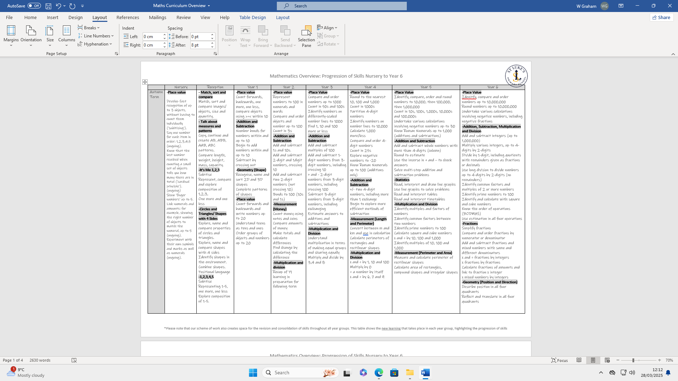

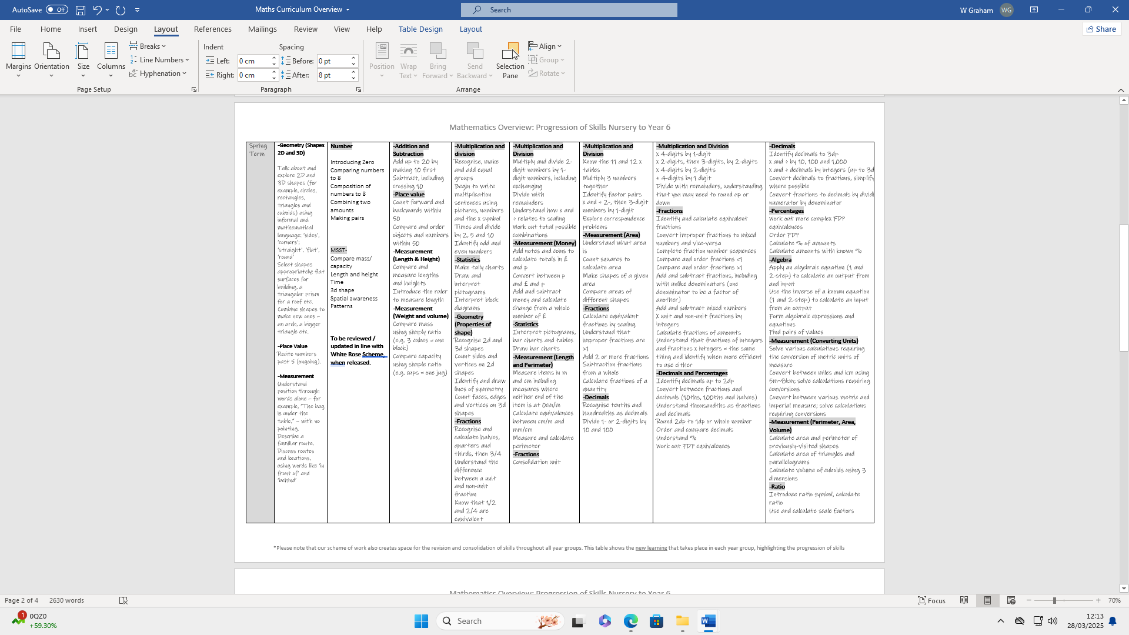

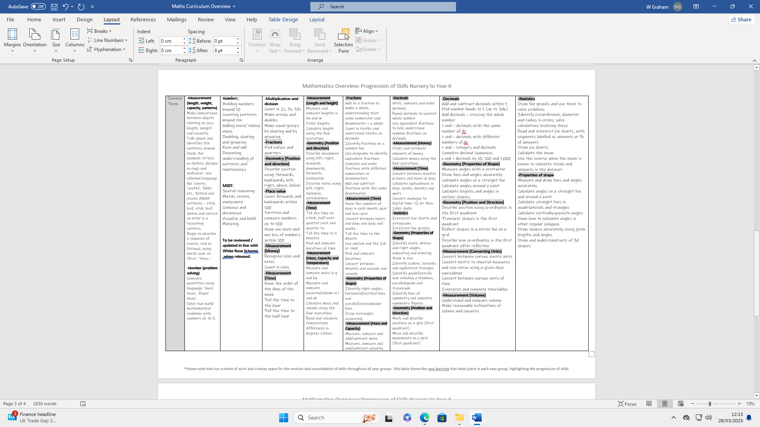

**Inclusion: How do we make sure that children with Special Educational Needs and Disabilities (SEND) are included in Mathematics?**

We are committed to ensuring that all pupils are able to access a broad, high quality curriculum. Pupils are likely to learn at different rates and require different levels and types of support. We seek to understand pupils’ differences, including their different levels of prior knowledge and potential barriers to learning. We use adaptive teaching where we focus on how teachers can help all learners reach the same goal and learn the same skills and concepts at their own individual level. In order to meet the additional needs of individual SEND pupils at St. Luke’s, we tailor resources, organise classroom environments and buy further resources as and when the need arises.

**SMSC and British Values: How do we promote British Values and the Spiritual, Moral, Social and Cultural development of pupils in Mathematics?**

SMSC and British values are promoted through our Maths curriculum. Awe and wonder in the logic and order of Maths are promoted in class, whilst mutual respect for all, regardless of innate ability, are actively encouraged.

**Safeguarding: How do we ensure that children are kept safe through our teaching of Mathematics?**

We promote the safeguarding and wellbeing of all of our children at all times throughout the curriculum. Our children are given opportunities to develop self-confidence and resilience; they are taught to challenge, question and make informed choices, and are given the relevant skills to resolve conflicts. Should any pupil make a disclosure, all staff are aware of the safeguarding policy and follow our safeguarding procedure.

**Impact: What do we expect to see for our pupils?**

Mathematics is key skill within school and a life skill that is used throughout our daily experiences; it equips us with a powerful set of tools to understand and change the world. These tools include logical reasoning, problem solving skills and the ability to think in abstract ways. At St Luke’s, we therefore endeavour to develop a positive attitude towards mathematics that will improve children’s confidence as they journey through their lives.

Each pupil is unique and levels attained in Mathematics will always vary, but we expect the vast majority of our pupils to be ‘secondary ready’, demonstrated by us keeping around or above national averages for attainment in Maths at the end of Key Stage 2.

This ensures that our pupils are given the foundational mathematics skills necessary to navigate the world with confidence and to be independent, positive contributors to society.

Where children are not expected to reach their age-related expectations, we prioritise the mathematics skills (such as time-telling and understanding of money) that we know will serve our pupils best in their adult lives. Our expectation is that all our pupils will pass through St Luke’s picking up the mathematics skills most important for their futures.

We expect all children, regardless of their attainment levels, to make tangible and encouraging progress that we can share with them and their parents/carers.

**Reading: How do we develop children’s reading skills in Mathematics?**

Reading has the highest priority in our school: the ability to read and comprehend fluently impacts on pupils’ ability to access Mathematics and to attain and achieve to their maximum potential. Poor reading skills are a limiting factor to pupils’ future life chances and the ability to deepen and widen their understanding of the world. In Maths, there is a wealth of new vocabulary for children to practise, learn and develop. In lessons, therefore, teachers are conscious that some language may be complex for children to understand. Consequently, every effort is made by teachers to embed and secure a deeper understanding of terminologies through the use of reading, investigations, research, discussion, etc. During Maths lessons children are given opportunities to practice many of the skills that mathematicians use such as arguing from evidence, communicating and evaluation information in addition to constructing explanations. Knowledge of vocabulary and Maths in general will help our pupils with their reasoning and problem-solving skills. As a result, opportunities are provided for our children to transfer their reading and writing skills in Mathematics.

**Communication and Language: How does our teaching of Mathematics promote the development of children’s communication and language skills?**

Secure communication and language skills are prioritised in our school as they bedrock of all subjects within St. Luke’s. Being competent and confident in these areas lays the foundation for a successful future for our children and it is essential that these skills are nurtured and developed at every stage of their schooling.

Language is fundamental to life and without it, limits experiences, reduces positive and purposeful interactions and creates additional challenge. Having a large bank of vocabulary helps children learn more. Words allow them to make sense of the world around them and therefore opens the doors of opportunity throughout their lives. Going hand in hand with language skills, communication skills are essential. If children cannot communicate effectively, they are limited in all areas of their school life, not only with regard to academic progression, but socially, emotionally and spiritually, too.

This is why we believe that, by fostering and developing the acquisition and understanding of communication and language skills, our children can effectively use words, share their emotions and communicate appropriately through body language, too. In turn, they will thrive and prosper, not only throughout their primary school careers, but- and perhaps more importantly- in their futures beyond.

**What opportunities are there for out of school learning in Mathematics?**

Our website contains a number of links which children can use at home to further their Maths learning. Weekly Maths homework is sent from Year 1 onwards, and all children in school have access to Times Tables Rock Stars, which has been proven to improve children’s fluency in their times tables.

**How is Mathematics assessed at St Luke’s?**

Our school has clear and streamlined monitoring and evaluation schedules which support a shared vision of what pupil progress looks like. Monitoring and evaluation schedules are made up of pupil voice activities, staff dialogue, work scrutiny, learning walks and lesson observations. Assessment in our school takes account of:

-Assessment data

-PPMs (Pupil Progress Meetings)

-Monitoring outcomes (pupil voice, work scrutiny, subject deep-dives)

This information is combined to support a deep understanding of school wide and individual needs.

Assessment informs our teaching in Maths and supports our children to develop and progress well. We assess in the following ways:

**[*Please make appropriate, subject-specific amendments as necessary*]**

* Assessment for Learning: Children are involved in the process of self-improvement, recognising their achievements and acknowledging where they could improve. Maths activities throughout each unit ensure progression, achievement and success.
* Active Feedback: Children receive immediate (or nearly immediate), specific feedback to support them to react, think analytically and develop well during learning sessions
* PPM meetings: Termly meetings allow teachers to discuss progress and achievement in Maths and support for children who may need additional intervention, or challenge
* Ongoing teacher assessment, reviewing children’s learning (performance, group work, written work) and pupil dialogue support Maths assessment
* Maths assessment is also supported by work scrutiny, lesson observations and pupil dialogue

Maths is assessed in the EYFS in accordance with statutory assessment of GLD (a ‘Good Level of Development’). In Year 1, teachers assess children’s attainment and progress for the first two terms against our KIPs (Key Indicators of Performance), before using teacher assessment alongside an NFER test suite in the summer term to give children a scaled score between 70 and 140.

From Year 2 to Year 5, children complete the NFER test suite three times a year (Autumn Term 1, Spring Term 1 and Summer Term 2). This gives them the scaled scores which are used alongside a teacher judgement.

In Year 6, past SATs are completed at various points in the year (usually September, January and April). These are used, alongside teacher judgements, to track children’s progress in the lead up to their statutory assessments in May.

Children’s levels are summarised as follows:

**Working below age-related expectations** (<85 NFER, <90 SATs)

**Working towards age-related expectations** (85-94 NFER, 90-99 SATs)

**Working at age-related expectations** (95-114 NFER, 100-109 SATs)

**Working at greater depth** (115+ NFER, 110+ SATs)

**How is the attainment and progress of children reported to parents and carers?**

Children’s levels are reported to parents and carers twice a year at Parents’ Evening (October and March) and then in their end of year reports (July)

**Attendance and Punctuality**

We actively support excellent attendance and punctuality at St Luke’s. We understand that poor attendance and punctuality can negatively affect children’s learning and achievements. There are many positive outcomes connected to good attendance and punctuality, including the positive impact on attainment, progress and achievement and excellent social and emotional wellbeing.

|  |  |
| --- | --- |
| **Document Control** | |
| **Title** | Mathematics Policy |
| **Date** | March 2025 |
| **Review** | September 2025 |