Providing parents, carers & family members, young people and teachers with information about learning, playing, performing & studying music in Manchester
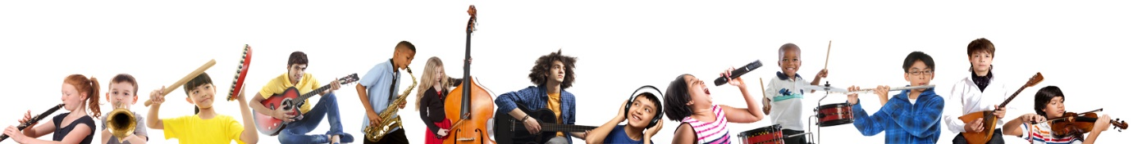

Please use the link below to find out how young people in Manchester can access music tuition, instrument loans, opportunities to play in musical ensembles and much more at one of several Manchester Music Hub music centres, supported by One Education.
My Music Hub

There are seven ‘Manchester Music Hub’ music centres across the city, run by One Education:
North Music Centre – based at the Co-op Academy of Manchester
North Steelpan & Percussion Centre – based at Co-op Academy North Manchester
South Music Centre – based at Chorlton High School
East Music Centre – based at The East Manchester Academy
Steelpan Music Centre based at St Margaret’s CE School in Whalley Range
Irish Music Centre based at St Mary’s RC School in Levenshulme
Kalinka Music Centre based at Chorlton Central Church

If you have any queries about the music centres, please contact One Education Music (music@oneeducation.co.uk)

